Chapter 8, Problem 33.

Find v(t) for t > 0 in the circuit in Fig. 8.81.

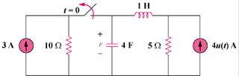

Figure 8.81
For Prob. 8.33.

